**Enabling AI with Legacy Systems: A Practical Guide to Interoperability**

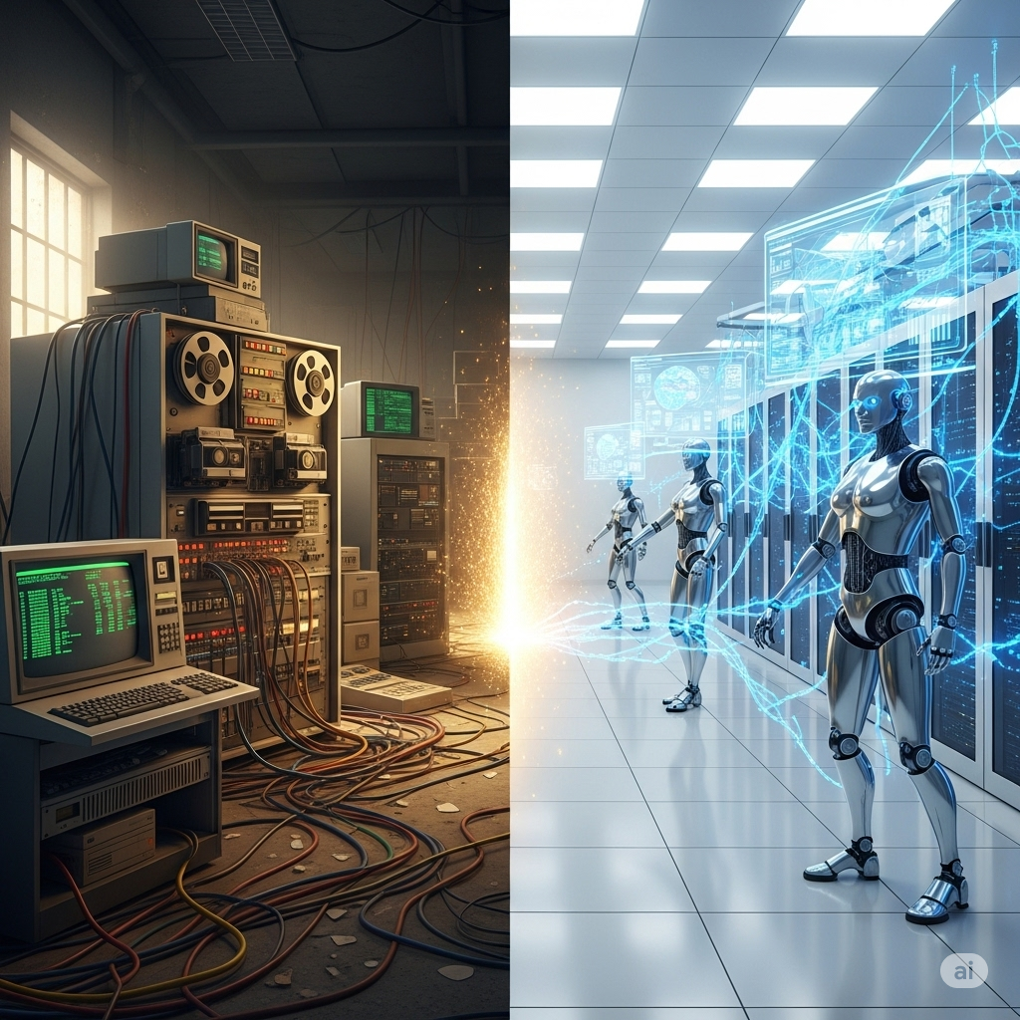

In today's fast-paced digital world, many enterprises are anchored to powerful, mission-critical systems built decades ago. These legacy systems, while robust and reliable, often exist in a state of digital isolation, disconnected from the modern wave of AI innovation. The challenge is not to discard these valuable assets but to forge a new path for them—one where they can seamlessly interact with intelligent agents, large language models, and AI-driven applications.

Forward-thinking product companies are already embracing this transition. For example, **Tricentis**, a leader in software testing, is implementing MCP-like frameworks to enable AI interoperability for its flagship products like **Tosca, qTest, and NeoLoad**. By exposing their core functionalities through a standardized protocol, they are opening the curtain for users to **co-create** features, build custom workflows, and develop by-products around the solutions that Tricentis offers.

Similarly, companies in the financial sector are using similar protocols to allow AI models to access and analyze legacy data for fraud detection and predictive analytics, while manufacturers are modernizing their plant control systems to enable AI-driven optimization and maintenance.

This article provides a detailed blueprint for enabling AI interoperability in legacy systems, outlining a phased, strategic approach. We will use a more realistic, yet relatable, Windows Desktop Calculator application as our case study to illustrate the journey from a standalone legacy tool to a fully AI-enabled service using the **Model Context Protocol (MCP)**.

**The Current State - A Digital Island**

The journey begins with the current reality of most legacy systems. They are self-contained "digital islands," designed for a different era of computing. User interaction is direct and manual, with functionality confined to the application's native user interface. This is a one-to-one relationship between the end-user and the application's logic.

In our example, the Windows Desktop Calculator is a powerful, multi-featured tool. A user opens the application and manually navigates its various functions—from basic addition to calculating sine or a square root. The application performs its function admirably but has no way to communicate with other systems or receive commands from external sources. It is a powerful, yet siloed, tool.

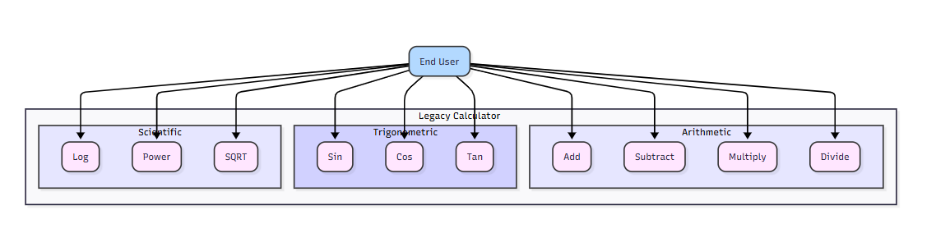

**Limitations of this state:**

* **No Automation (most cases):** Operations cannot be automated or scripted by other applications.
* **Limited Integration:** The system cannot be part of a larger digital workflow.
* **No AI Potential:** AI models cannot access or leverage the core logic of the system, trapping valuable data and functionality.

**The Mid-Way State - Breaking Down the Walls with APIs**

The first step in modernization is to create a digital bridge to the outside world. This involves building a thin, modern API layer on top of the legacy system's core functionalities. Instead of a full-scale rewrite, we encapsulate the existing logic and expose it through a standardized protocol like **REST**.

For our calculator, this would mean developing a lightweight API with separate endpoints for each feature set. For example, a /arithmetic endpoint for addition and subtraction, and a /trigonometric endpoint for sine and cosine. This allows other software applications or services to programmatically access the calculator's specific functions. The end-user can still use the familiar desktop application, but now, a new class of "actors" can interact with its functions via the API.

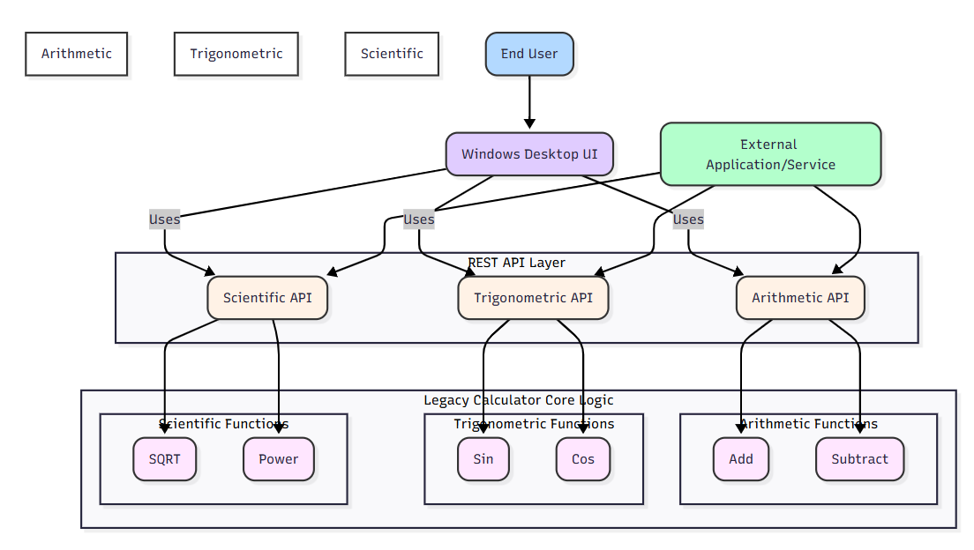

**Benefits of this state:**

* **Partial Automation:** Allows other systems to automate tasks like batch calculations.
* **New Integration Opportunities:** The calculator's logic can now be integrated into other applications, such as an e-commerce platform for tax calculations or a scientific data processing tool.
* **Improved Reach:** The application's core functionality is no longer confined to a single machine.

**Limitations of this state:**

* **Lack of Context:** Traditional APIs are stateless and lack the contextual awareness that modern AI models require. They can perform a single function but cannot participate in a complex, multi-step conversation with an AI agent.
* **Integration Complexity:** Each new integration requires custom code, leading to an "M×N problem" where the number of required integrations grows exponentially.
* **No Rich Interactivity:** This model is designed for simple input-output transactions, not for the dynamic, conversational, and context-aware interactions that AI models excel at.

**The Target State - True AI Interoperability with Layered Architecture**

The final and most transformative phase is the integration of the **Model Context Protocol (MCP)** through a layered architecture. This is the key to unlocking true AI interoperability. Unlike a simple API, MCP provides a structured, standardized way for AI models to understand the capabilities of an external system and interact with it in a context-aware manner.

This approach uses a centralized **MCP Server** and two distinct **MCP Clients** to manage communication securely and efficiently. An **External MCP Client** serves as the public-facing interface for the AI agent, while an **Internal MCP Client** resides within the system, translating commands for the legacy application's core logic.

An MCP-enabled system acts as a "tool" for an AI agent. The AI can dynamically discover what the calculator can do (e.g., add, sqrt, sin), understand its inputs and outputs, and use it as part of a larger, more complex task.

In our example, an AI agent could take a user's natural language request like, "What is the sine of 90 degrees times 10?", and decompose it into a series of steps.

The AI would first identify the need for both the sin function and a multiplication. It would then use the **External MCP Client** to send this request to the **MCP Server**. The server would relay the command to the **Internal MCP Client**, which would then invoke the sin function with an input of 90, get the result (1), and then use the multiply function to calculate 1 * 10. The end user could be a human, a chatbot, or another AI.

**The Transformative Benefits of the Target State**

Moving to an MCP-enabled architecture is not just a technical upgrade; it's a strategic shift that delivers significant business value:

* **Unlocking New Functionalities:** The legacy system can now power entirely new, AI-driven use cases, such as:
  + **Natural Language Calculations:** Users can simply type or speak their calculation, and an AI can use the calculator to process it, even for complex, multi-step problems like "what is the power of 2 to the 10th plus the cosine of 45?"
  + **Automated Data Processing:** An AI can read data from a spreadsheet, perform complex calculations using the calculator's many functions, and automatically generate a report.
  + **Predictive Assistance:** An AI can analyze a user's input and proactively suggest calculations or offer related information, turning the calculator from a passive tool into an active assistant.
* **Enhanced User Experience:** Interactions become more intuitive and conversational. Users can get work done faster by leveraging AI automation, reducing manual input and errors.
* **Future-Proofing Your Investment:** MCP is an open standard designed to solve the M×N problem of AI integrations. By adopting it, you build a single, standardized interface that works with a growing ecosystem of AI models and tools, ensuring your legacy assets remain relevant and adaptable for years to come.
* **Increased Agility:** Developers can build new AI-powered features much faster. Instead of custom coding each integration, they can simply connect a new AI model to the existing MCP interface, accelerating time-to-market for new services.

**The Phased Implementation Roadmap**

1. **Discovery & Prioritization:**
   * **Task:** Conduct a thorough audit of the legacy system to map out all its features and functions.
   * **Goal:** Identify core functions that, when exposed, will yield the highest return on investment.
   * **Deliverable:** A prioritized list of features for API development (e.g., all Arithmetic functions first, then key Scientific and Trigonometric ones).
2. **API Development & Deployment:**
   * **Task:** Build and deploy a secure RESTful API layer with dedicated endpoints for each functional group.
   * **Goal:** Make the legacy system's logic accessible to external applications.
   * **Deliverable:** A well-documented set of APIs for key functionalities.
3. **MCP Integration & Tooling:**
   * **Task:** Implement the MCP on top of the newly created API layer.
   * **Goal:** Enable the system to be "discovered" and used as a tool by AI agents.
   * **Deliverable:** A functional MCP server that encapsulates the calculator's capabilities.
4. **Pilot AI Application & User Feedback:**
   * **Task:** Build a simple pilot AI application (e.g., a chatbot) that uses the MCP-enabled system.
   * **Goal:** Validate the new architecture and gather early user feedback.
   * **Deliverable:** A proof-of-concept AI application demonstrating the new capabilities.
5. **Scaling & Expansion:**
   * **Task:** Extend the MCP integration to other legacy systems and new AI models.
   * **Goal:** Create a unified, intelligent ecosystem that leverages your entire digital footprint.
   * **Deliverable:** A company-wide strategy for AI interoperability and continuous improvement.

By following this blueprint, organizations can systematically transform their legacy assets from isolated relics into powerful, interoperable components of a modern, intelligent enterprise, paving the way for a future where technology works for you, not against you.

**The Future is Not a Single Protocol**

While the Model Context Protocol (MCP) provides a robust and standardized approach, it’s not the only technology evolving in the space of AI interoperability. The field is rapidly maturing with several frameworks and techniques that empower AI models to interact with external tools and data sources. Instead of a single standard, we are seeing a diverse ecosystem of solutions, each with its own strengths.

**Other Evolving Technologies**

* **OpenAI's Function Calling:** One of the most prominent examples, this feature allows developers to describe functions to an OpenAI model (like GPT-4) in a simple JSON schema. The model can then intelligently decide when to "call" these functions to retrieve information or perform actions on a user's behalf. It's a pragmatic and powerful way to give an LLM "tool use" capabilities without building an entire protocol from scratch.
* **Agent Frameworks (LangChain, LlamaIndex, etc.):** These open-source frameworks are essentially toolkits for building AI agents. They provide pre-built components for connecting to various data sources (databases, APIs, PDFs) and orchestrating complex, multi-step workflows. They function as a layer between the LLM and the external world, managing tasks like data retrieval, chain of thought, and tool execution. While they aren't a standardized protocol like MCP, they provide a powerful, code-based way to achieve the same interoperability goals.
* **JSON Schema:** At the heart of many of these technologies, including MCP and OpenAI's function calling, is the use of JSON Schema. It's a standard format for describing the structure of JSON data. By defining a schema for a tool's inputs and outputs, you can ensure that the AI model receives and generates predictable, well-formed data, drastically reducing errors and making integrations more reliable.

**Conclusion: A Call to Action for Readers**

The journey from a legacy application to an intelligent, interoperable system is a marathon, not a sprint. The good news is that you don't need to wait for a single, universal standard to emerge. The technologies are already here.

* **Educate Yourself:** Start by exploring the frameworks mentioned above. Familiarize yourself with how tools are defined and how they can be integrated into a larger AI workflow.
* **Pilot a Project:** Don't try to modernize your entire system at once. Pick a small, well-defined function in your legacy application, create a simple API for it, and then experiment with connecting it to an AI model using one of the available frameworks.
* **Advocate for Interoperability:** Whether you're a developer, a product manager, or an executive, champion the idea of open, standardized APIs and tool definitions within your organization. The future of enterprise technology is not about building the next closed ecosystem, but about building intelligent components that can work together.